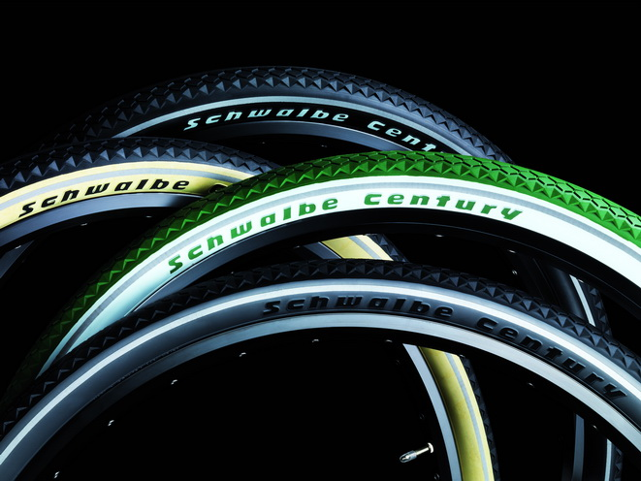

Provides the finishing touch to modern classics: The authentically styled Schwalbe Century with side walls in billboard technology.
Photo: Schwalbe

Century for Modern Classics
Modern technology and classic design combine to form the new Schwalbe Century tire. At the beginning of the 20th century a bicycle culture existed in many European countries. This first heyday of cycling remembers bikes in a vintage style and modern interpretations such as lifestyle bikes, fixies or Dutch bikes in unusual colours. Schwalbe pays homage to these early days of bike culture with the new Century, whose profile and contour detail are based on the tires of the early 20th century.
The highlight: the side wall in traditional billboard technology is achieved with raised lettering in a contrasting colour attaining a somewhat 3-D look. If you like it traditional, black tires are finished with a cream sidewall. The tires with silver-grey side walls again finish the look of the lifestyle bike. And the British Racing Green variant in combination with white gives classic bikes a distinguishing look! With reflective strips, 50 EPI carcass and K-Guard.
The Schwalbe Century is available at a price of 24.90 euros from professional bicycle shops. The four colour variants of Black-reflex, Racing Green / White and Black with side walls in cream or silver grey, are all available in sizes 37-622 and 50-622. Other Size: 28-622 in Black-reflex.

This press release with photos and Graphics can be downloaded from: www.schwalbe.com/en/presse.html

SCHWALBE - Ralf Bohle GmbH  Doris Klytta
Otto-Hahn-Straße 1  51580 Reichshof-Wehnrath
Telefon: +49 2265 109-57  Fax: +49 2265 7022
d.klytta@schwalbe.com  www.schwalbe.com

